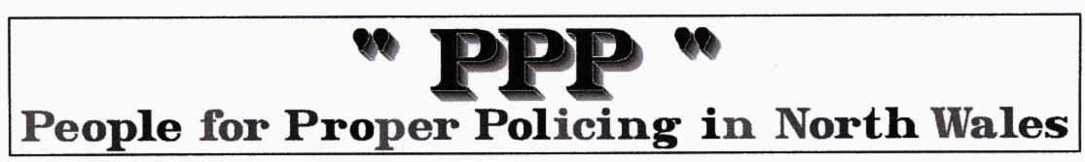
Does anyone smile on public transport ?

A mother of 3 called a BBC radio 5 Live phone in on the subject of car use. At the age of 41 she had recently passed her test and bought her first car. Her exact words were;

“After 20 years of walking and waiting for buses in the rain with my three children, having my little car has changed my life, my life is so much easier”

She went on to say;

“I worked out that it’s actually cheaper now for me to run my car then to use public transport”

Despite the obvious benefit in terms quality of life, in some quarters this family would be reclassified as ‘car dependent’ and even branded ‘antisocial’.

While organisations like the Campaign for Better Transport don’t seem to value individual quality of life, academic research suggests that they are wrong. Gurley and Bruce (2005) found that access to a car;

“generally increased the probability of being employed and leaving benefit. Car access also leads to more hours of work for benefit recipients with a work requirement and enabled participants to find better-paying jobs”.

Government funded research published by the Medical Research Council’s social and public health sciences unit in Glasgow found that driving is good for you. Its report said that;

“car drivers benefited from increased self-esteem, sense of security and control over their lives.”

and that; “….after eliminating the effects of age, social class and income, we found drivers to have better general health and less depression than people who used public transport.”

(Ironically, the purpose of the report was to reduce our reliance on private cars and to promote public transport)

Another popular line of attack is based upon the work of academic John Urry whose book ‘After the car’ predicts the end of our car based culture within a couple of decades. He claims that drivers have ‘sealed themselves away from the outside world in steel boxes’ which has contributed to a break down in social interaction and society.

As regular public transport users will testify; rather then being the catalyst for the coming together of divergent elements of society that Urry and others claims suggest, the average public transport user is confronted with rows of sullen individuals glued to their ipods with the one common denominator being they all wish they were somewhere else.

When was the last time you saw anyone smile?, instigate a conversation with a stranger or generally interact with their fellow passengers on a bus or train?

History has taught us that in the pursuit of ideology or profit, personal wellbeing is the first casualty, certainly the woman’s choice to transform her life and improve the quality of her family’s life through car ownership would be viciously attacked by the CfBT,. Thankfully, the vast majority of people would call the choice to travel by the fastest, most convenient, safest, most cost effective, most efficient and most comfortable mode of transport as plain common sense.

After all it’s Great Britain we want not Grey Britain.

The PPP comments … we travel the world and wherever we go personal transport is the life blood of the communities. In the world’s great cities the public transport systems take over and move us around like so many cattle to feed the commercial machine that cities are. Here the rule is DO NOT EVEN MAKE EYE CONTACT! BUT elsewhere the road systems are like the arteries of the body from the main arteries to the smallest capillary they carry the people and the vital goods and services that make for a civilised society. Whether it be by IC or electric or nuclear power it is vital. Here in the UK the ‘patients’ circulation is deteriorating such as to be life threatening and misguided Government at all levels and departments including the Police are restricting the flow at every opportunity.

We repeat ad nauseum … The PPP believe that the whole population are 'Motorists' in the sense that they are either pilots or passengers in vehicles of one sort or another whether it be Bikes, Cars, PSVs, HGVs, ESVs. and all the numerous vans that provide goods and services to every corner of these Isles, AND we really need each other!

